CO – 2
EXP – 5 OB – 1
To analyze Fourier series of continuous-time periodic signals and analyze their waveform characteristics.
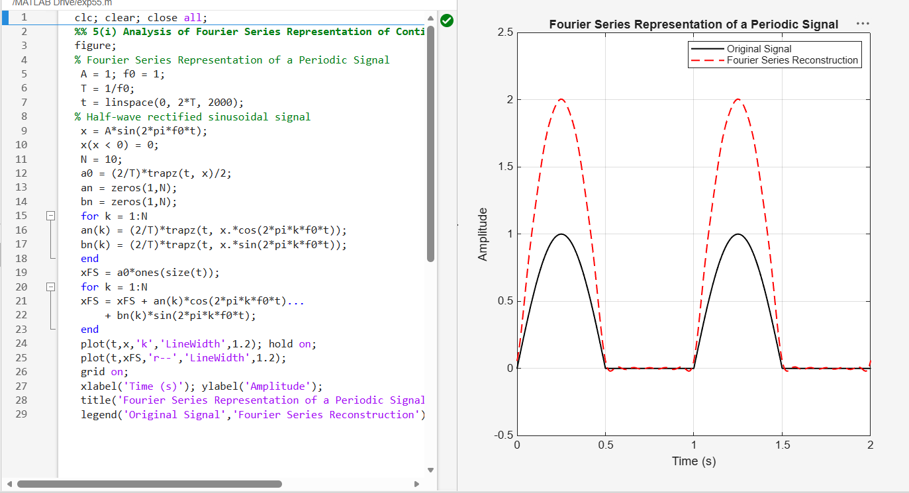
EXP – 5 OB – 4
To reconstruct periodic signals using Fourier series and verify the reconstructed waveform with the original signal.

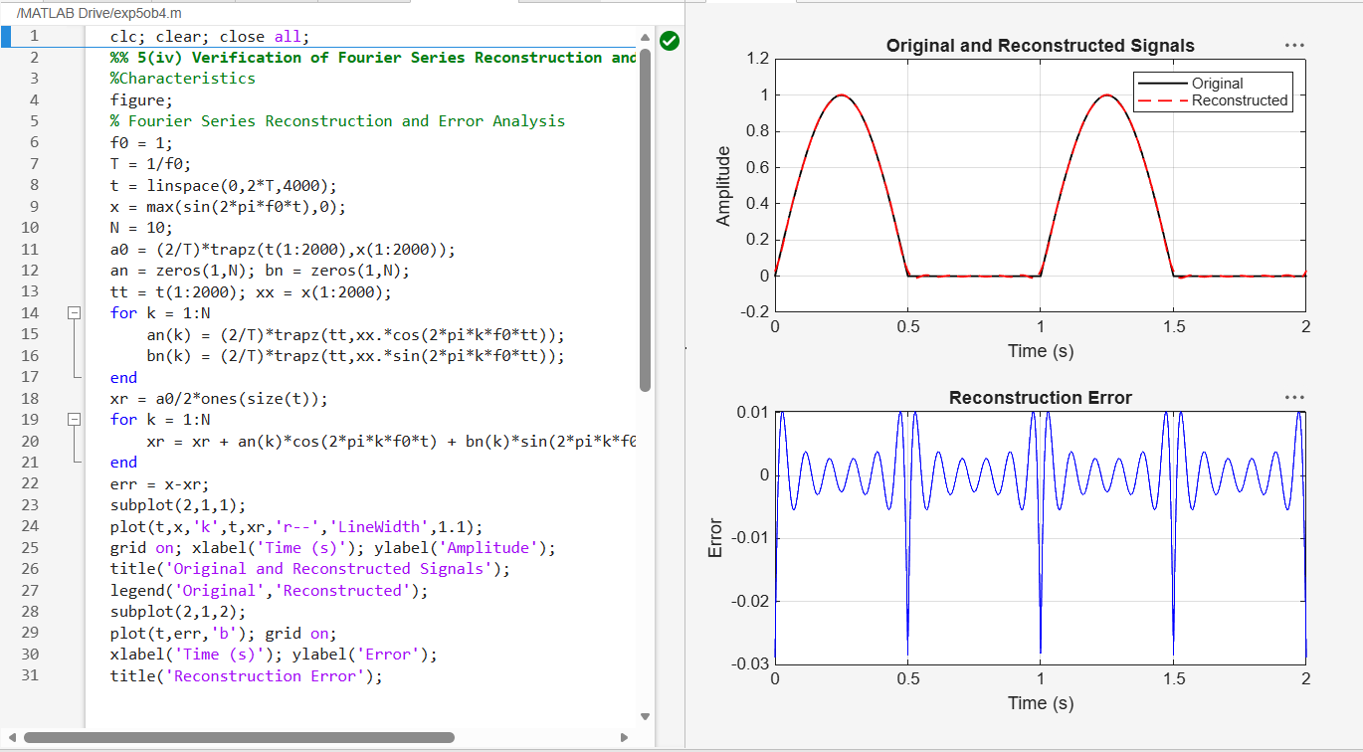
EXP – 6 OB – 1
To verify Parseval’s relation for continuous-time periodic signals and analyze the relationship between time-domain and frequency-domain power.

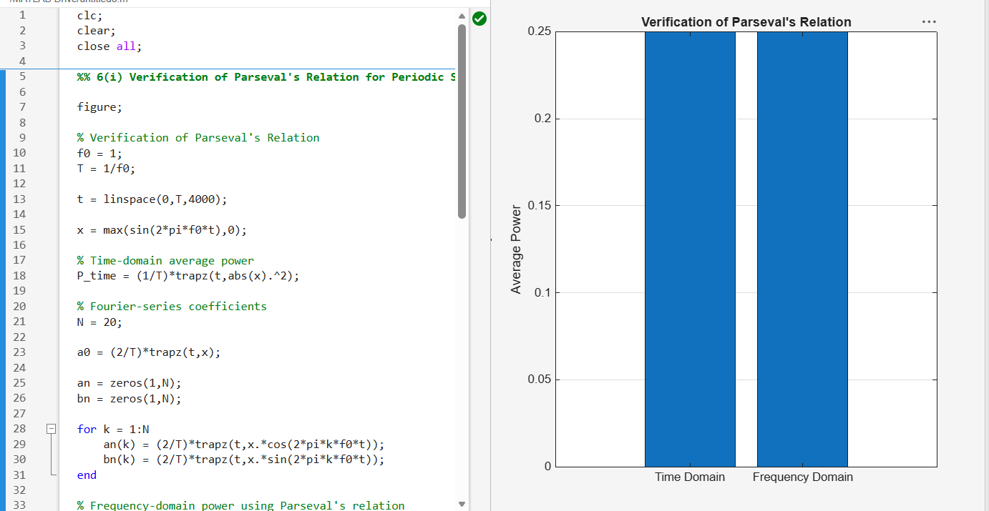
EXP – 6 OB – 4
To compare the total power obtained in the time domain with the harmonic power distribution in the frequency domain.

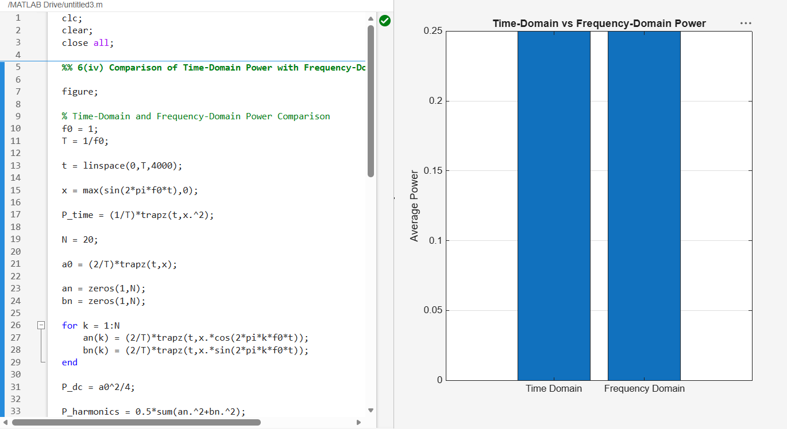

EXP – 7 OB – 2
To determine the magnitude and phase spectra of continuous-time signals and analyze their significant spectral components.

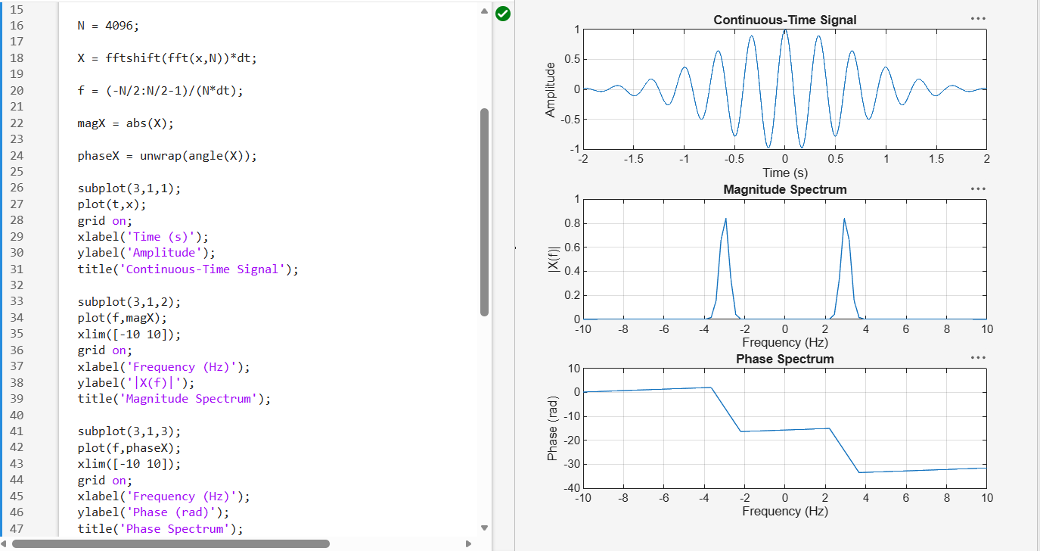
EXP – 7 OB – 3
Verification of Fourier Transform Properties and Frequency-Domain Characteristics

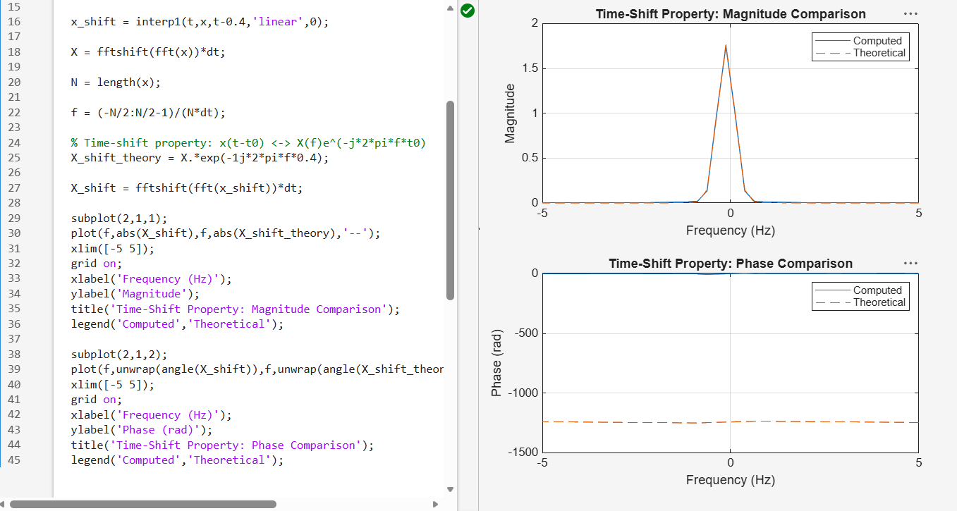

EXP – 8 OB – 2
To determine the inverse Laplace transform of a given frequency-domain representation and reconstruct the corresponding time-domain signal.

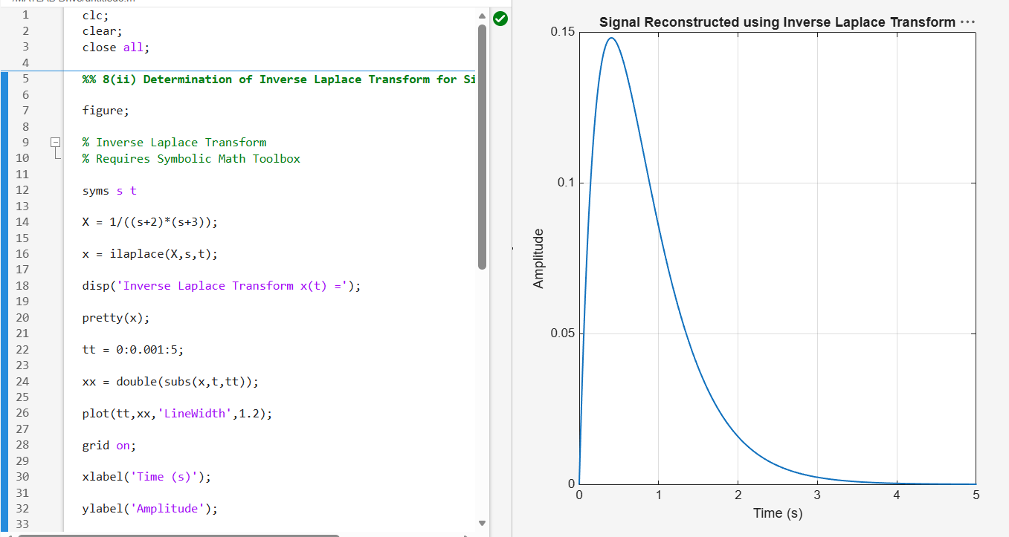
EXP – 8 OB – 3
To determine the Region of Convergence (ROC) of Laplace transforms and analyze its significance in characterizing continuous-time signals and systems.

